In vitro Selection for a Max 1s DNA Genetic Algorithm
Junghuei Chen, Eugene Antipov, Bertrand Lemieux, Walter Cedeno,
David Harlen Wood
DIMACS series in discrete mathematics and theoretical computer science, pp. 23-37, 1999
Abstract
Genetic algorithms, DNA computing, and In vitro evolution are briefly discussed. Elements of these are combined into laboratory procedures, and preliminary results are shown. The traditional test problem for genetic algorithm called the MAX 1s problem is discussed. Preliminary experimental results indicate successful laboratory “separation by fitness” of DNA encoded candidate solutions.
- Definition of the Max 1s problem
- Input: a set containing binary strings of fixed length.
- Output: some bitstrings which match a prespecified “target” (generally taken to be all 1s)
- Implementation of the Max 1s Problem with DNA
- Design of candidate solutions and target DNA strands:
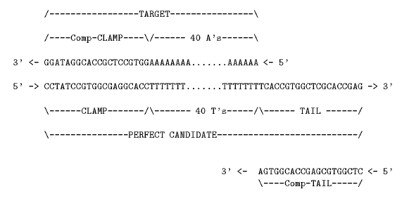
- Outline of DNA implementation of GA for max 1s problem:
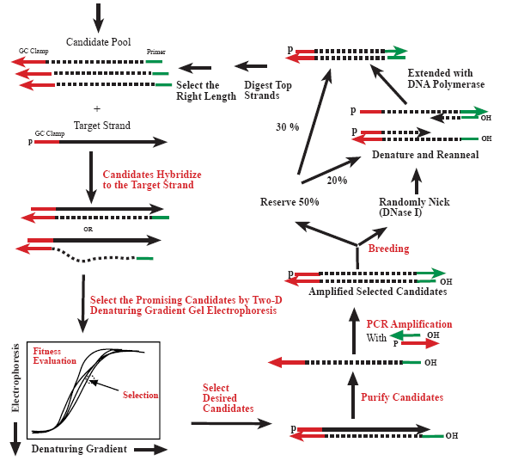

- Selection of more fit candidate solutions
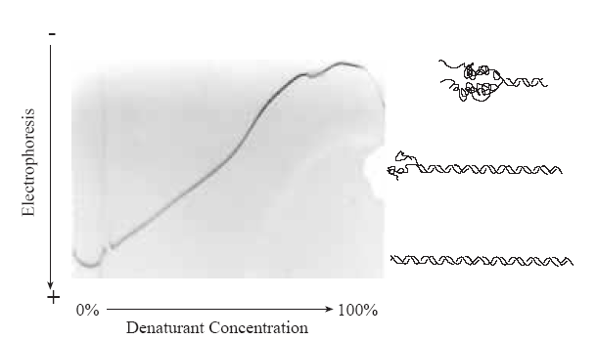
  - The selected DNA can be purified by digesting target strands.
These strands are fabricated with phosphorylated 5` ends, they can bee selectively digested by - exonuclease.
- Amplification with mutation via PCR

target

candidate

+

+
Candidate strands can be extended at an exponential rate

- Breeding using single point crossover :

+

- Readout of candidate pool:

+

the primer is extended in the 3` direction by including Taq polymerase and including radioactive nucleotides. The primers are extended as long as the candidate contains only Ts, and extension stops upon encountering any

Perfect candidate

+
Complement-clamp

nick

Extract the correct strands by PCR

3. Conclusion
Created by : Hung –Wei Huang
Date : Mar. 25, 2004

